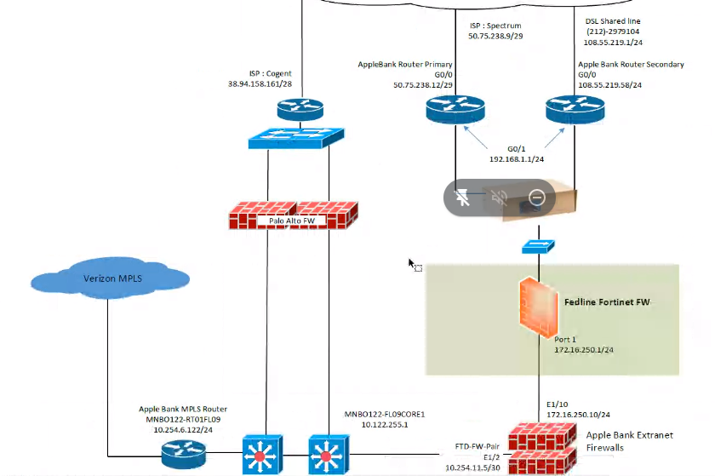

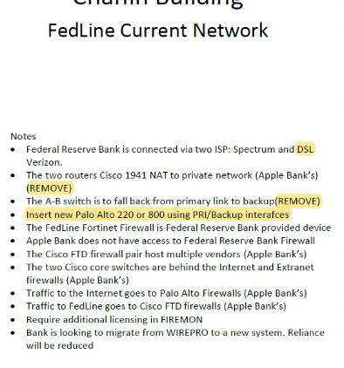

FUTURE STATE by end of February 2022

Palo Alto Stateful between VPN and Internet